Exercise 14
- Our Ceo fall in love with the petite Web Developer, Anamika Pandit. She now wants her last name to be changed to ‘Sharma’.
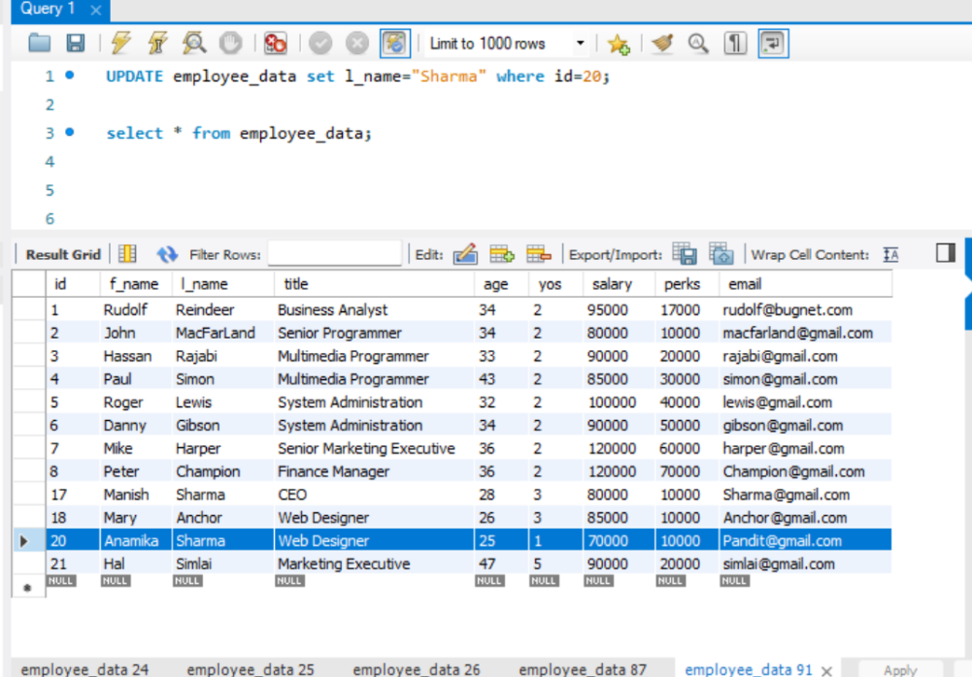
- All Multimedia Programmers now want to be called Multimedia Specialists.

- After his marriage, the CEO gives everyone a raise. Increase the salaries of all employees (except the CEO) by $10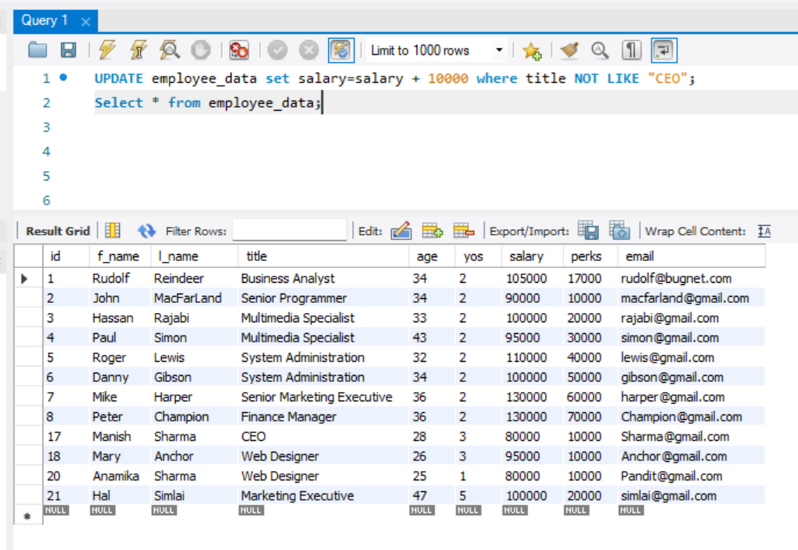000.

